Article title

Abstract

The abstract should be a concise but complete reflection of your article. The abstract should indicate the nature and contribution of the study. In particular, the abstract must be autonomous, without abbreviations, formulations, footnotes, or references. Make sure your abstract reads well and is grammatically correct. The abstract should be between 150 and 250 words, and the keyword list should be between 3 to 5 words separated by commas. The maximum number of pages should be 15 for full research papers and 10 for research papers in progress, including references. This template is referential.

Keywords: keyword1, keyword2.

Resumen

El resumen debe ser un reflejo conciso pero completo de lo que hay en su artículo. El resumen debe indicar la naturaleza y contribución del estudio. En particular, el resumen debe ser autónomo, sin abreviaturas, formular, notas a pie de página ni referencias. Asegúrese de que su resumen se lea bien y sea gramaticalmente correcto. El resumen debe tener entre 150 y 250 palabras. La lista de palabras claves debe ser entre 3 a 5 palabras separadas por comas. El número máximo de páginas deberá ser 15 para los trabajos de investigación completos y 10 para trabajos de investigación en progreso, incluidas las referencias. La presente plantilla es referencial.

Palabras clave: palabra clave 1, palabra clave 2.

1. Introduction

This template can be used to write your article in Microsoft Word, and it is recommended to use the Microsoft Word formula editor. Try to put a paragraph at the end of the section that briefly describes the parts of your article.

2. Method

The reference format to be used will be APA, for example: According to the work of Anderson (1983)…. or at the end of the appointment place (Anderson, 1983).
IMPORTANT: We recommend using the APA Standard guide published by the University of Lima, available at the link:
http://contenidos.ulima.edu.pe/bibliofiles/gsu/Guias_tutoriales/citas_referencias_apa.pdf
The guide provides cites and references in texts, figures, and tables.

3. Experimentation (optional section)

You can consider this section to present the implementation of the proposed solution and a proposal of the set of techniques to validate the experiments or the implementation carried out.

4. Results

Insert the graphics in the software format in which they were originally created or as a high-resolution image. For example, in the case of diagrams, you can attach the source file created either in Microsoft Word, PowerPoint, or Adobe Illustrator. In the case of images, you should consider sending them in jpg or png format, with a minimum resolution of 300 dpi and a minimum size of 190 mm.
IMPORTANT You must allow the tables and figures to be editable, or the texts of the figures must be grammatically correct and be of adequate size to be read.

Figure 1
Example of graph

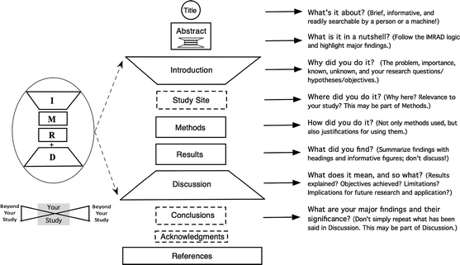

Note. Data were taken from the repository published in Kandinsky (2009).

Table 1
Algorithmic response time

f(n) | 10 | 20 | 30 | 40 | 50
N | 0.00001 seg. | 0.00002 seg. | 0.00003 seg. | 0.00004 seg. | 0.00005 seg.
n2 | 0.0001 seg. | 0.0004 seg. | 0.009 seg. | 0.0016 seg. | 0.0025 seg.
n3 | 0.001 seg. | 0.008 seg. | 0.027 seg. | 0.064 seg. | 0.125 seg.
n5 | 0.1 seg. | 3.2 seg. | 24.3 seg. | 1.7 min. | 5.2 min.
2n | 0.001 seg. | 1 seg. | 17.9 min. | 17.7 días | 35.1 años
Note. Results of the experiment according to the methodology of Aguilar (2013).

In the case of mathematical equations, use the Microsoft Word equation editor, and you must list the formulas.

$\frac{dB}{d_{t}}=-∝^{A}$ (1)

Figure 2
The graphs or images must be well legible

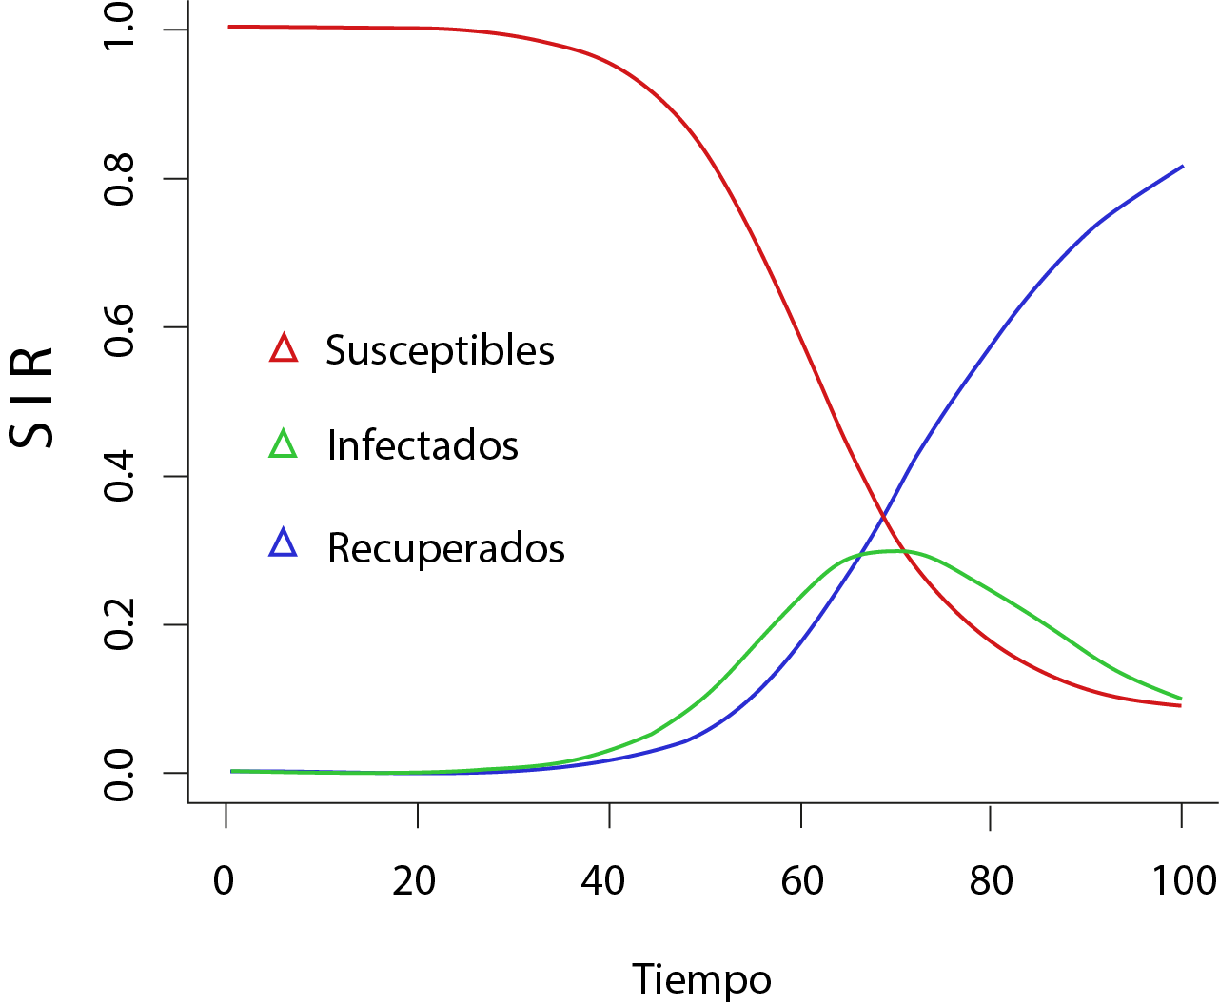
Note. Available in Sánchez (2020).

In the tables and the figures, you must indicate the source or tell your elaboration.
5. Discussion of the Results

You may consider the discussion section to put your results into context based on the literature review presented.

6. Conclusions

Place your conclusions, recommendations, and future work in this section.

References

Akcil, U., Uzunboylu, H., & Kinik, E. (2021). Integration of Technology to Learning-Teaching Processes and Google Workspace Tools: A Literature Review. Sustainability, 13(9). https://doi.org/10.3390/su13095018
Al-Omar, K. (2018). Evaluating the Usability and Learnability of the “Blackboard” LMS Using SUS and Data Mining. 386-390. https://doi.org/10.1109/iccmc.2018.8488038
Google for Education. (28 de agosto del 2020). Capacitación sobre aspectos básicos. https://skillshop.exceedlms.com/student/path/111629-capacitacion-sobre-aspectos-basicos
Hernández Sampieri, R., Fernández Collado, C., & Baptista Lucio, M. del P. (2010). Metodología de la investigación (Quinta). McGRAW-HILL.
Mendoza, S. H. V. (2015). Improving Communication and Building Communities with Google [Presentación de paper]. Proceedings of the 2015 ACM SIGUCCS Annual Conference, 85-90. https://doi.org/10.1145/2815546.2815574
Nielsen, J. (1994). Usability Engineering. Elsevier Science. https://books.google.com.pe/books?id=95As2OF67f0C
Nina, H., Enciso, L., y Chavez, W. A. (2017). Software as a Service Google Apps in the Internal Communication of the National University of San Antonio Abad del Cusco [Presentación de paper]. Proceedings of the International Conference on Industrial Engineering and Operations Management Bogota, Colombia, October 25-26, 2017, 701-710. http://ieomsociety.org/bogota2017/papers/113.pdf
Nina, H. (2019). Implementación de un nuevo modelo de servicio computacional para mejorar la comunicación interna Universitaria Nacional de San Antonio Abad del Cusco [Tesis de Doctorado, Universidad Nacional Federico Villarreal]. Repositorio Institucional de la Universidad Nacional Federico Villarreal. http://repositorio.unfv.edu.pe/handle/UNFV/3335
Plataforma digital única del Estado Peruano. (11 de agosto del 2021). Normatividad sobre coronavirus (COVID-19). https://www.gob.pe/institucion/minsa/colecciones/749-normatividad-sobre-coronavirus-covid-19
UNESCO. (2021). COVID-19: Reopening and reimagining universities, survey on higher education through the UNESCO National Commissions. https://unesdoc.unesco.org/ark:/48223/pf0000378174.locale=en

IMPORTANT: References must be presented in APA format, in alphabetical order, and strictly correspond to the citations included in the article. References to articles published in journals or conference proceedings, including the DOI if available or the URL of the source. You must ensure that you do not leave an unreferenced citation or an uncited reference in the manuscript.

